**Final Term Paper (Spring-2023)**

**BSCS/BSSE [4th /6th Semester] (Mor/Eve)**

**Computer Networks ( CS-577 )**

**Theory**

**Name: ___________________ Max. Marks: 30**

**Reg. No.: ________________ Time: 1.5 hr**

**----------------------------------------------------------------------------------------------------------------------------------**

**Note:** You can solve questions in any order but all parts should be together and to the point answers are required.

**Question N0. 1 [Marks: 1+1+3+1=6]**

1. You are designing a network for a bank that requires real-time communication for their financial transactions. Which switching method would you recommend, circuit switching or packet switching? Justify your choice.
2. A customer is making a voice call from their landline telephone to a mobile phone. Explain how circuit switching would be used in this scenario.
3. A satellite communication system is being designed to serve multiple users. The available frequency band is 30 MHz, and the system needs to support three user groups with dedicated bandwidth and channel. Group A requires a bandwidth of 11 MHz, Group B requires a bandwidth of 11 MHz, and Group C requires a bandwidth of 11 MHz. The system is considering three different multiple access techniques: FDMA, TDMA and CDMA. Which multiple access technique would be most suitable for the satellite communication system and justify your answer.
4. In Twisted Pair cable, Cat-6 and Cat-7 both can support speed at 10Gbps, then why Cat-7 is better and costly?

**Question N0. 2 [Marks: 2x4=8]**

|  |  |  |
| --- | --- | --- |
| Destination Net | Netmask | Interface |
| 128.96.39.0 | 255.255.255.128 | m2 |
| 128.96.39.128 | 255.255.255.128 | m0 |
| 128.96.40.0 | 255.255.255.128 | m3 |
| 192.4.153.0 | 255.255.255.192 | m1 |
| default |  | m4 |

A routing table in a router is as following:

Compute the interface for each of the following destinations:

1. 128.96.39.196
2. 128.96.40.151
3. 192.4.153.17
4. 192.4.153.100

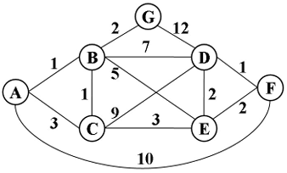**Question N0. 3 [Marks: 8]**

Consider the following figure. Using Dijkstra’s algorithm, find the routes from node A to all other nodes. Show all the steps and generate a routing table of A, B and D.

**Question N0. 4 [Marks: 2+6=8]**

1. Differentiate between flow control and congestion control
2. Draw a graph for TCP congestion control for both i) TCP Tahoe ii) TCP Reno based on the following information. Also show SS(Slow start) & CA(Congestion Avoidance) phases on graph.

At round 1, CWND =1 MSS,

Initial SSThreshold =36

3 Duplicate ACK = At round 11,

Timeout = At round 19,

Total rounds =26

**\*\*\*\*Good Luck\*\*\*\*\***

**Final Term Paper (Spring-2023)**

**BSCS/BSSE [4th /6th Semester] (Mor/Eve)**

**Computer Networks ( CS-577 )**

**Practical**

**Name: ___________________ Max. Marks: 20**

**Reg. No.: ________________ Time: 1.0 hr**

**----------------------------------------------------------------------------------------------------------------------------------**

**Note:** You can solve questions in any order but all parts should be together and to the point answers are required.

**Question N0. 1 [Marks: 1+2.5+2.5+2.5+1.5=10]**

You are given a pool of 192.168.1.0/24 IP addresses to assign to hosts and routers in the system drawn below:

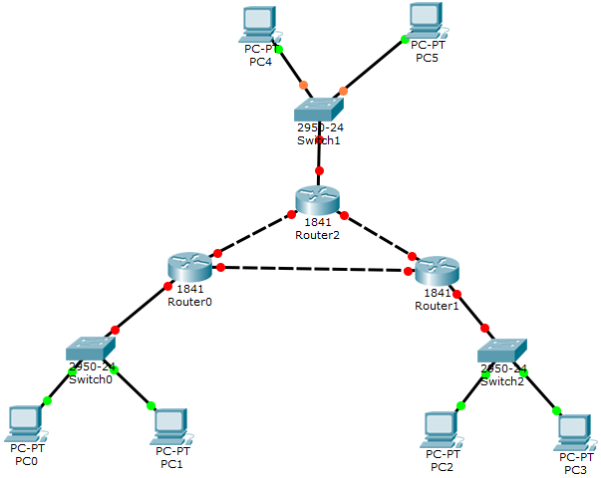

1. How many separate networks are in the system?
2. Partition the given address space (Lower left subnet need 100IP’s, Lower right subnet needs 60IP’s and upper subnet needs 20IP’s) and assign addresses to the networks. To answer this question properly you should write down the addresses of all of the networks in the A.B.C.D/x format.
3. Assign addresses to components of the network. To answer this question you should label all of the interfaces in the diagram with their assigned addresses.
4. Write down the commands to configure the Router0 for assignment of IP address and dynamic routing(assuming other 2 routers are already configured).
5. The configuration should be done in a way that the PC 0&1 can ping PC 2&3. Also write the response of ping sent by the destination to source.

**Question N0. 2 [Marks: 1+0.5+0.5=2]**

Convert the following IP address from binary to decimal in correct IP representation form.

1. 11001101 00010000 00100101 00100111
2. What is its class?
3. Is it public or private?

**Question N0. 3 [Marks: 8]**

Write Introduction of your semester project (4-5 lines and Mandatory to write on answer sheet).